

CyberShield 360: Design and Analysis of an AI-Enabled Enterprise Cybersecurity Platform
Submitted in the partial fulfilment for the Course of

CSA1012 – Software Engineering

to the award of the degree of

BACHELOR OF TECHNOLOGY

Submitted by
P.Sai Surya Tej (192572044)

UNDER THE SUPERVISION OF
Dr. K. Anita Davamani

SIMATS ENGINEERING
Saveetha Institute of Medical and Technical Sciences
Chennai-602105
July-2026

ACKNOWLEDGEMENT

We would like to express our heartfelt gratitude to all those who supported and guided us throughout the successful completion of our Capstone Project. We are deeply thankful to our respected Founder and Chancellor, Dr. N.M. Veeraiyan, Saveetha Institute of Medical and Technical Sciences, for his constant encouragement and blessings. We also express our sincere thanks to our Pro-Chancellor, Dr. Deepak Nallaswamy Veeraiyan, and our Vice-Chancellor, Dr. S. Suresh Kumar, for their visionary leadership and moral support during the course of this project.

We are truly grateful to our Director, Dr. Ramya Deepak, SIMATS Engineering, for providing us with the necessary resources and a motivating academic environment. Our special thanks to our Principal, Dr. B. Ramesh for granting us access to the institute’s facilities and encouraging us throughout the process. We sincerely thank our Head of the Department, Dr K. Anita Davamani for his continuous support, valuable guidance, and constant motivation.

We are especially indebted to our guide Dr K. Anita Davamani for his creative suggestions, consistent feedback, and unwavering support during each stage of the project. We also express our gratitude to the Project Coordinators, Review Panel Members (Internal and External), and the entire faculty team for their constructive feedback and valuable inputs that helped improve the quality of our work. Finally, we thank all faculty members, lab technicians, our parents, and friends for their continuous encouragement and support.

Signature With Student Name
P. Sai Surya Tej (192572044)

Abstract

The rapid growth of digital transformation, cloud computing, and interconnected enterprise systems has significantly increased the complexity and frequency of cyber threats. Traditional cybersecurity solutions, which primarily rely on signature-based detection and manual analysis, are no longer sufficient to identify sophisticated attacks such as ransomware, phishing, insider threats, Advanced Persistent Threats (APTs), and zero-day vulnerabilities. Enterprise Security Operations Centers (SOCs) face the challenge of analyzing massive volumes of security logs generated from networks, endpoints, cloud platforms, and applications, resulting in delayed incident detection, fragmented visibility, and slower response times.
This case study presents CyberShield 360, an AI-powered Enterprise Cybersecurity Monitoring and Threat Intelligence System designed to enhance organizational security through intelligent automation and real-time threat detection. The proposed platform integrates Artificial Intelligence (AI), Machine Learning (ML), behavioral analytics, and global threat intelligence feeds to continuously monitor enterprise infrastructure, detect anomalous activities, predict potential cyber threats, and automate incident response. By correlating security events from multiple sources, the system minimizes false positives, improves threat visibility, and enables proactive security management.
The proposed solution follows software engineering principles such as modularity, scalability, maintainability, reliability, usability, and security to ensure the development of a robust and enterprise-ready cybersecurity platform. An Agile Scrum development methodology integrated with DevSecOps practices is recommended to support continuous development, rapid deployment, and evolving security requirements. The platform includes modules for data collection, AI-based threat detection, threat intelligence integration, automated response, compliance management, and interactive security dashboards.
The expected outcomes of CyberShield 360 include faster threat detection, reduced incident response time, improved regulatory compliance, enhanced protection against advanced cyberattacks, and greater operational efficiency for security teams. Although challenges such as implementation cost, AI model maintenance, legacy system integration, and privacy concerns remain, the proposed platform provides a scalable and intelligent approach to strengthening enterprise cybersecurity. Overall, CyberShield 360 demonstrates how AI-driven technologies and software engineering practices can be combined to build a modern, resilient, and proactive cybersecurity solution capable of addressing the evolving threat landscape.

Table of Contents
(Right-click below and choose "Update Field" / "Update Table" after opening in Word to generate page numbers.)
Code of Conduct 2
Table of Contents 3
1. Executive Summary 5
2. Project Overview 6
3. CI/CD Objectives 7
4. CI/CD Requirements Analysis 8
4.1 Functional CI/CD Requirements 8
4.2 Non-Functional CI/CD Requirements 8
5. Proposed CI/CD Architecture 10
5.1 Branching Concepts 10
6. Pipeline Stages 11
6.1 Stage 1 - Source Code Management 11
6.2 Stage 2 - Continuous Integration Trigger 11
6.3 Stage 3 - Build 11
6.4 Stage 4 - Unit Testing 11
6.5 Stage 5 - Static Code Quality Analysis 11
6.6 Stage 6 - Dependency and Software Composition Analysis 12
6.7 Stage 7 - Secret Detection 12
6.8 Stage 8 - Container/Image Build 12
6.9 Stage 9 - Container Security Scanning 12
7. Automated Testing Strategy 13
7.1 Unit Testing 13
7.2 Integration Testing 13
7.3 API Testing 13
7.4 System Testing 13
7.5 Regression Testing 13
7.6 Security Testing 13
7.7 Performance Testing 13
7.8 AI/ML Testing 14
8. DevSecOps Integration 15
9. Tool and Technology Selection 16
10. Tool Justification 18
11. CI/CD Pipeline Diagram 19
12. Environment Strategy 21
13. Deployment Strategy 22
13.1 Recommended Strategy 22
14. Quality Gates 23
15. Security Strategy 24
16. Secrets Management 25
17. Artifact Management 26
18. Rollback Strategy 27
18.1 Rollback Categories 27
18.2 Rollback Triggers 27
19. Monitoring and Observability 29
20. Notification Strategy 30
21. Branching Strategy 31
22. CI/CD Workflow - End-to-End 32
23. Failure Handling 33
24. AI/ML Model CI/CD (MLOps / AI Model Delivery Pipeline) 34
25. Ethics and Responsible DevOps 35
26. Reliability and Business Continuity 36
27. Pipeline Security Threat Model 37
28. CI/CD Pipeline Metrics 39
29. Sample Pipeline Configuration 40
30. Traceability Matrix 42
31. Rubric Mapping 43
32. Conclusion 44
33. References 45

1. Executive Summary
CyberShield 360 is a proposed AI-based enterprise cybersecurity monitoring and threat intelligence platform designed to observe network traffic, endpoints, cloud resources, and user activity, while applying machine-learning models to detect malware, phishing, ransomware, insider threats, and anomalous behaviour. Because the platform is intended to protect an organisation's most sensitive infrastructure, the way it is built, tested, secured, and released is as important as the features it offers.
Traditional manual deployment relies on ad-hoc builds, inconsistent testing, and human-driven release steps. For a system of this scope, that approach is insufficient: manual processes are slow, error-prone, difficult to audit, and cannot reliably enforce security checks before every release. A Continuous Integration / Continuous Delivery (CI/CD) pipeline addresses these gaps by automating the path from source code to production in a consistent, repeatable, and auditable way.
Automation increases development speed by removing repetitive manual steps and giving developers fast feedback on every change. It improves software quality by running unit, integration, and regression tests on every commit rather than occasionally. Because CyberShield 360 is itself a cybersecurity product, its delivery pipeline must additionally practise DevSecOps: security scanning (SAST, SCA, secret detection, container scanning, DAST) is embedded directly into the pipeline instead of being treated as a final checkpoint, so that vulnerable or insecure builds are stopped before they reach staging or production.
Automated testing reduces the number of defects that reach later stages, while explicit security gates prevent builds containing critical vulnerabilities, exposed secrets, or unscanned container images from being promoted. Staged deployment - moving a build through Development, Staging, and Production with increasing levels of validation and approval - reduces the risk of a defective or insecure change directly impacting live enterprise monitoring. Finally, continuous monitoring and a well-defined rollback strategy ensure that if a release does cause a problem in production, it can be detected quickly and reverted with minimal impact on the organisation's security posture.
Note: This document is an academic CI/CD design exercise for CyberShield 360. No pipeline has actually been built or executed, and no build, test, security, or model results reported here are real; all tool choices are proposed design decisions.

2. Project Overview
CyberShield 360 is conceived as an AI-based enterprise cybersecurity monitoring and threat intelligence system. Based on the assigned problem statement, the system is expected to provide the following capabilities:
- Enterprise security monitoring
- Network traffic monitoring
- Endpoint monitoring
- Cloud resource monitoring
- User activity monitoring
- Security log collection
- AI/ML-based threat detection
- Malware detection
- Phishing detection
- Ransomware detection
- Insider-threat detection
- Anomaly detection
- Behavioural analysis
- Threat prediction
- Threat intelligence integration
- Risk assessment
- Incident detection
- Incident prioritisation
- Automated response
- Security dashboards
- Security analytics
- Reporting
- Compliance support
- Business continuity

Note: Proposed Architecture / Design Assumption: specific implementation technologies (languages, frameworks, cloud provider) are not fixed by the original problem statement. Wherever a concrete technology is named in this document, it is a proposed design choice for illustration, not a confirmed implementation fact.
Because CyberShield 360 combines real-time monitoring, AI/ML inference, and incident response, its CI/CD pipeline must support frequent, low-risk releases of both conventional application code and machine-learning models, while maintaining continuous protection of live enterprise environments.

3. CI/CD Objectives
The CI/CD pipeline for CyberShield 360 is designed to meet the following objectives, each of which is directly traceable to CO4 (robust testing, quality assurance, and DevOps practice emphasising security, reliability, and ethics):
- Automate code integration across contributors
- Automate builds for consistent, reproducible artifacts
- Automate testing (unit, integration, regression, security)
- Automate code-quality analysis
- Automate security scanning at every relevant stage
- Automate artifact creation and versioning
- Automate deployment across Development, Staging, and Production
- Reduce deployment errors through repeatable automation
- Detect defects as early as possible (shift-left)
- Prevent insecure code from reaching production
- Support frequent, low-risk releases
- Maintain traceability from requirement to deployed artifact
- Enable rapid, controlled rollback
- Improve overall system reliability
- Support scalable deployment as monitored infrastructure grows
- Enable continuous monitoring and feedback
- Support responsible, auditable AI/ML model delivery

4. CI/CD Requirements Analysis

4.1 Functional CI/CD Requirements
ID | Requirement | Type | Priority | CI/CD Impact
CI-CD-FR-01 | Source code version control | Functional | High | Enables branching, review, and history for all changes
CI-CD-FR-02 | Automated build | Functional | High | Produces a consistent, reproducible build on every commit
CI-CD-FR-03 | Automated unit testing | Functional | High | Validates individual components before integration
CI-CD-FR-04 | Integration testing | Functional | High | Validates interaction between monitoring, AI, and dashboard modules
CI-CD-FR-05 | Security scanning | Functional | Critical | Detects code, dependency, secret, and container vulnerabilities
CI-CD-FR-06 | Code-quality analysis | Functional | Medium | Flags bugs, smells, and maintainability issues early
CI-CD-FR-07 | Artifact packaging | Functional | High | Creates immutable, versioned deployable artifacts
CI-CD-FR-08 | Deployment automation | Functional | High | Removes manual, error-prone release steps
CI-CD-FR-09 | Environment promotion | Functional | High | Moves the same artifact through Dev, Staging, Production
CI-CD-FR-10 | Approval controls | Functional | Critical | Requires human sign-off before high-impact releases
CI-CD-FR-11 | Automated rollback | Functional | Critical | Restores last stable release on failure
CI-CD-FR-12 | Deployment notification | Functional | Medium | Informs the team of pipeline outcomes in real time
CI-CD-FR-13 | Monitoring | Functional | High | Confirms production health after every release
CI-CD-FR-14 | Audit logging | Functional | High | Provides a traceable record for compliance and review
CI-CD-FR-15 | AI/ML model validation | Functional | Critical | Confirms model quality before promotion to production

4.2 Non-Functional CI/CD Requirements
- Security
- Reliability
- Availability
- Scalability
- Performance
- Maintainability
- Auditability
- Traceability
- Reproducibility
- Recoverability
- Deployment consistency
- Compliance
- Data protection

ID | Requirement | Type | Priority | CI/CD Impact
CI-CD-NFR-01 | Security | Non-Functional | Critical | Every pipeline stage must resist and detect compromise
CI-CD-NFR-02 | Reliability | Non-Functional | High | Pipeline must produce consistent, dependable outcomes
CI-CD-NFR-03 | Availability | Non-Functional | High | Monitoring platform must remain available during releases
CI-CD-NFR-04 | Scalability | Non-Functional | Medium | Pipeline must scale with growing monitored infrastructure
CI-CD-NFR-05 | Reproducibility | Non-Functional | High | Builds must be reproducible from source at any time
CI-CD-NFR-06 | Recoverability | Non-Functional | Critical | Failures must be recoverable via rollback within minutes
CI-CD-NFR-07 | Auditability | Non-Functional | High | Every pipeline action must be logged and traceable

5. Proposed CI/CD Architecture
The proposed conceptual pipeline workflow for CyberShield 360 is as follows:
Note: Developer -> Git Repository -> CI Trigger -> Build -> Unit Tests -> Static Code Analysis -> Dependency Scan -> Secret Scan -> Container Build -> Container/Image Scan -> Integration Tests -> Package/Artifact Repository -> Staging Deployment -> Security/Acceptance Tests -> Approval/Gate -> Production Deployment -> Monitoring -> Feedback/Rollback
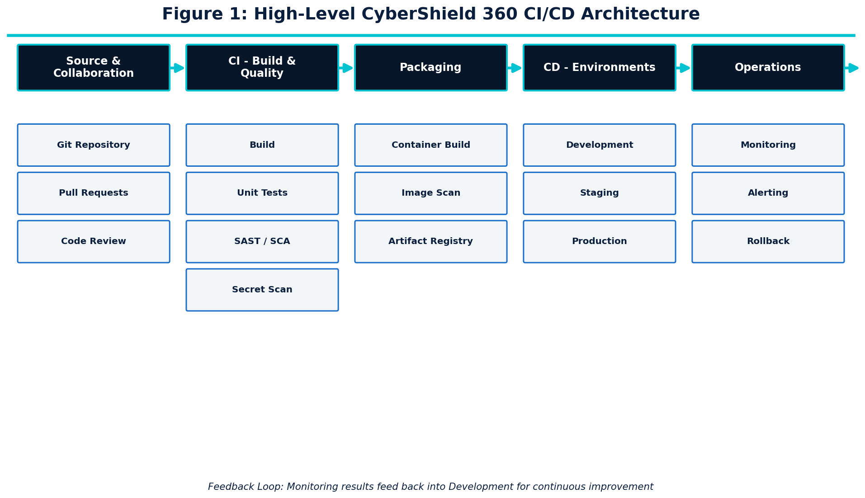
Figure 1: High-Level CyberShield 360 CI/CD Architecture

5.1 Branching Concepts
- main - always reflects the current production-ready state of the codebase.
- develop - integration branch where completed features are merged and validated together.
- feature/* - short-lived branches for individual features or fixes, merged via reviewed pull requests.
- release/* - stabilisation branches cut from develop to prepare a specific release for staging and production.
Keeping the architecture straightforward - a single linear promotion path with clear gates - avoids unnecessary complexity while still satisfying CyberShield 360's security and reliability needs.

6. Pipeline Stages

6.1 Stage 1 - Source Code Management
- Central Git repository as the single source of truth
- Branching strategy (main / develop / feature / release)
- Pull requests required for all changes to protected branches
- Mandatory code review before merge
- Automated commit validation (linting, commit message checks)
- Branch protection rules preventing direct pushes to main
- Semantic version tagging of releases
Note: Proposed tool choice: GitHub / GitLab / Bitbucket (any may be substituted; the exact platform is a design choice, not a fixed requirement).

6.2 Stage 2 - Continuous Integration Trigger
- Push trigger - runs the pipeline on every commit to a working branch
- Pull request trigger - validates proposed changes before merge
- Merge trigger - runs full validation when code reaches develop or main
- Manual trigger - available for on-demand runs (e.g., hotfix validation)
- Scheduled trigger - periodic security scans independent of code changes
Note: Automated triggering removes reliance on developers remembering to run checks manually, ensuring every change receives the same level of validation regardless of urgency.

6.3 Stage 3 - Build
- Dependency installation from a locked manifest
- Compilation / build of application components
- Build validation against expected artifacts
- Reproducible builds - identical input produces an identical artifact
- Immediate pipeline failure and notification on build error

6.4 Stage 4 - Unit Testing
- Automated execution of unit tests for every module
- Machine-readable test reports for traceability
- Code coverage measurement against a minimum threshold
- Pipeline fails when critical/blocking unit tests fail

6.5 Stage 5 - Static Code Quality Analysis
- Code style and formatting checks
- Cyclomatic complexity and maintainability scoring
- Bug and code-smell detection
- Quality gate: build fails on new critical issues
Note: Proposed tool choice: SonarQube / SonarCloud.

6.6 Stage 6 - Dependency and Software Composition Analysis
- Scans all third-party dependencies for known vulnerabilities
- Flags outdated dependencies with available patches
- Identifies known vulnerable libraries against public CVE databases
- Optional license compliance checks
- Severity thresholds determine whether the pipeline is blocked

6.7 Stage 7 - Secret Detection
- Scans commits and configuration for API keys, passwords, and tokens
- Detects accidentally committed private keys or cloud credentials
- Blocks the pipeline immediately if a secret is detected
- Reinforces the principle that secrets must never be stored in source code
Note: Proposed tool choice: Gitleaks or an equivalent secret-scanning tool.

6.8 Stage 8 - Container/Image Build
- Builds a Docker image from a minimal, hardened base image
- Applies consistent image tagging and semantic versioning
- Produces immutable artifacts - an image is never modified after build
- Avoids unnecessary packages to reduce attack surface
Note: Proposed Architecture / Design Assumption: containerisation is proposed here as a suitable deployment model; it is not specified as mandatory in the original problem statement.

6.9 Stage 9 - Container Security Scanning
- Scans for OS package vulnerabilities inside the image
- Scans application-level dependencies bundled into the image
- Flags insecure configuration (e.g., running as root)
- Blocks promotion on critical, unpatched CVEs
- Optional image signing to verify provenance before deployment
Note: Proposed tool choice: Trivy or an equivalent container scanner.

7. Automated Testing Strategy

7.1 Unit Testing
Purpose: validate individual functions and components in isolation. Trigger: every commit and pull request. Pass/fail criteria: all critical unit tests must pass; the pipeline halts on failure.

7.2 Integration Testing
Integration tests validate interaction between:
- Monitoring components
- Threat intelligence integration
- AI detection engine
- Incident management
- Dashboard
- Notification system

7.3 API Testing
API tests validate:
- Authentication
- Authorization
- Input validation
- Error handling
- Response correctness

7.4 System Testing
End-to-end system tests validate complete CyberShield 360 workflows, such as detecting a simulated threat, generating an alert, and surfacing it on the security dashboard.

7.5 Regression Testing
Regression tests execute automatically on every merge to develop and before any staging/production promotion, ensuring previously working functionality has not been broken by new changes.

7.6 Security Testing
- SAST (Static Application Security Testing)
- SCA (Software Composition Analysis)
- Secret scanning
- Container image scanning
- DAST (Dynamic Application Security Testing) in Staging

7.7 Performance Testing
- Event-processing throughput under load
- Alert-generation latency
- Dashboard responsiveness
- Behaviour under high event volume (load/stress testing)

7.8 AI/ML Testing
Model-specific validation gates are proposed to include:
- Model validation against a held-out test dataset
- Accuracy
- Precision
- Recall
- F1-score
- False-positive rate
- False-negative rate
- Drift checks against production data distribution
- Model version validation before registry promotion
Note: No actual AI/ML performance metrics are reported in this document. The metrics listed above are proposed quality-gate categories only, to be populated with real measurements once the system is implemented and evaluated.

8. DevSecOps Integration
A core design principle of this pipeline is that security is integrated throughout the pipeline rather than performed only before production deployment ('shift-left' security).
Pipeline Stage | Security Activity | Purpose
Commit | Secret Scan | Prevent credential leakage
Build | SAST | Detect code-level vulnerabilities
Dependencies | SCA | Detect vulnerable third-party libraries
Container Build | Image Scan | Detect image and OS-level vulnerabilities
Staging | DAST | Validate the running application for exploitable issues
Deployment | Access Control | Prevent unauthorised deployment actions
Production | Monitoring | Detect operational and security issues in real time

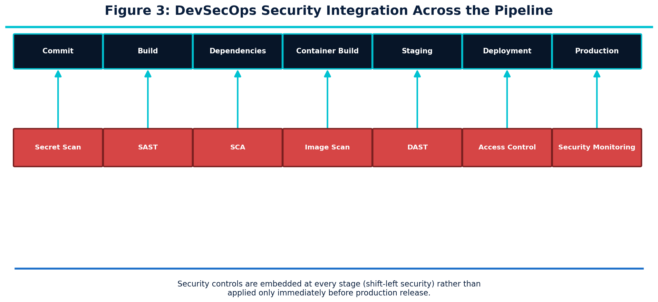
Figure 3: DevSecOps Security Integration Across the Pipeline
This distributed security model directly supports CO4 by embedding testing, quality assurance, and security practice into every automated stage of delivery, rather than treating them as an afterthought.

9. Tool and Technology Selection
The following toolchain is proposed for CyberShield 360. No tool listed here is claimed to be mandatory; each represents a suitable, industry-standard option, with viable alternatives noted.
Tool | Pipeline Stage | Purpose | Why Selected | Alternative | Security/Quality Benefit
Git + GitHub/GitLab | Source Control | Version control and collaboration | Event-driven, integrates with CI natively, supports branch protection | Bitbucket | Traceability, code review enforcement
GitHub Actions / GitLab CI / Jenkins | CI/CD Orchestration | Automates the full pipeline | Native SCM integration, parallel jobs, supports quality/security gates | CircleCI, Azure DevOps | Consistent, automated delivery
Maven / Gradle / npm | Build | Dependency management and build | Matches proposed implementation language/ecosystem | Bazel | Reproducible builds
SonarQube | Code Quality | Static quality analysis | Configurable quality gates, tracks maintainability over time | CodeClimate | Early bug/smell detection
JUnit / PyTest / Jest | Unit Testing | Automated unit test execution | Matches proposed implementation language | Mocha, TestNG | Fast feedback on defects
Postman/Newman | API Testing | Automated API validation | Scriptable, CI-friendly collection runner | REST Assured | Confirms API correctness
OWASP ZAP | DAST | Dynamic security testing in staging | Open-source, CI-integrable, actively maintained | Burp Suite | Detects runtime vulnerabilities
OWASP Dependency-Check / Snyk | SCA | Dependency vulnerability scanning | Maps dependencies to known CVEs | Black Duck | Prevents vulnerable libraries in production
Gitleaks | Secret Scanning | Detects committed secrets | Fast, CI-friendly, configurable rules | TruffleHog | Prevents credential leakage
Docker | Containerisation | Packages the application consistently | Industry standard, immutable artifacts | Podman | Deployment consistency
Trivy | Container Security | Scans container images | Broad CVE database, fast, CI-integrable | Grype | Blocks vulnerable images
GitHub Packages/Nexus | Artifact Repository | Stores versioned artifacts | Centralised, access-controlled storage | JFrog Artifactory | Artifact integrity and promotion
Kubernetes / Docker Compose | Deployment | Runs application workloads | Scalable, supports rolling/canary/blue-green | Cloud-managed container services | Scalability, controlled rollout
Terraform | Infrastructure as Code | Provisions infrastructure | Declarative, versioned infrastructure changes | Pulumi | Reproducible environments
Prometheus + Grafana | Monitoring | Metrics collection and dashboards | Open-source, widely adopted, alerting support | Datadog | Continuous health visibility
ELK/OpenSearch | Logging | Centralised log aggregation | Full-text search over pipeline and app logs | Splunk | Audit and incident investigation
Email / Teams / Slack | Notifications | Pipeline and incident alerts | Integrates with most CI/CD platforms | PagerDuty | Timely team awareness
Note: No specific tool is claimed to be mandatory for CyberShield 360; the selections above represent one reasonable, justified toolchain among several valid options.

10. Tool Justification
Beyond simply listing tools, each major selection is justified below against CyberShield 360's needs.

GitHub Actions / GitLab CI
Proposed because it provides event-driven workflow automation, integrates directly with source control, supports parallel jobs, allows security scanning integration, and can enforce quality gates before deployment - all essential for a fast-moving, security-sensitive platform.

SonarQube
Selected for its configurable quality gates and long-term maintainability tracking, which help prevent complexity and technical debt from accumulating in a system that must remain auditable and easy to secure.

OWASP Dependency-Check / Snyk
Chosen because CyberShield 360 depends on numerous third-party libraries for monitoring and AI/ML functionality; automated CVE mapping is essential to prevent known-vulnerable components from reaching production.

Gitleaks
Selected because CyberShield 360 handles sensitive credentials (threat-intel API tokens, cloud credentials); automated secret detection is a low-cost, high-value control against accidental leakage.

Trivy
Chosen for container image scanning because containerised deployment is proposed for scalability, and image-level vulnerabilities are a common supply-chain risk that must be caught before promotion.

OWASP ZAP
Selected for dynamic testing in staging because static analysis alone cannot detect certain runtime vulnerabilities (e.g., authentication flaws) that matter greatly for a security-focused platform.

Prometheus + Grafana
Proposed for monitoring because continuous visibility into event-processing latency, alert generation, and system health is essential for a platform whose core purpose is availability and rapid incident response.

Kubernetes (or equivalent)
Proposed for deployment because it natively supports rolling, canary, and blue-green strategies, health checks, and automated rollback - directly supporting the reliability goals of CO4.

11. CI/CD Pipeline Diagram
The diagram below shows the complete end-to-end pipeline, including both quality/security gate decision points, so it can be understood without reading the rest of the document.

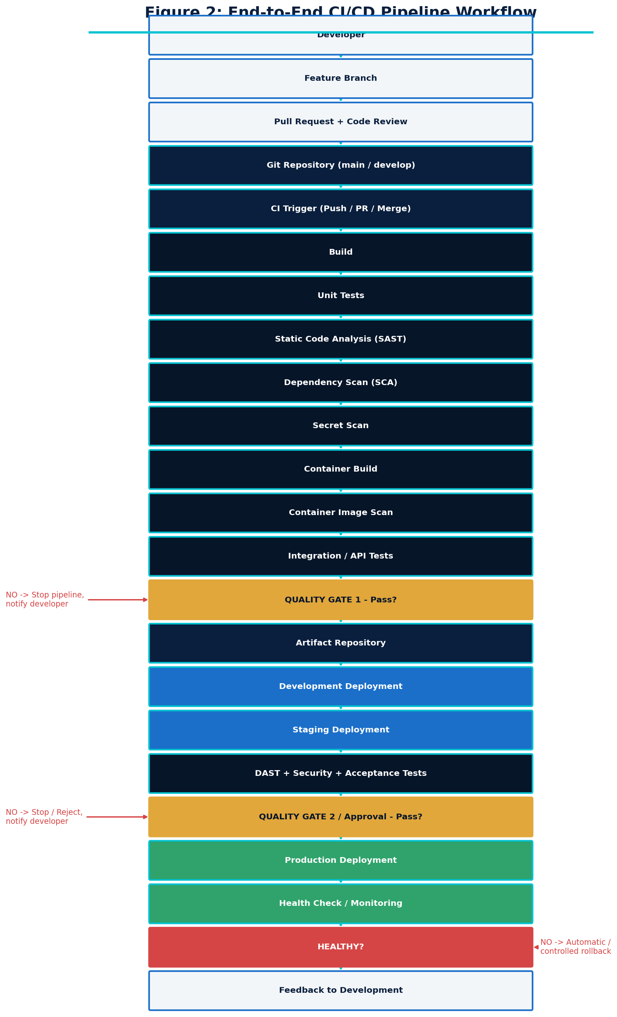
Figure 2: End-to-End CI/CD Pipeline Workflow

12. Environment Strategy
Environment | Deployment Trigger | Access Control | Data Policy | Testing Performed | Approval | Monitoring | Rollback
Development | Merge to develop branch | Developers / internal team | Synthetic or masked data only | Unit, smoke, and integration tests | None (automatic) | Basic health checks | Redeploy previous build
Staging/Test | Release branch created / promoted build | Restricted to QA & release team | Production-like, anonymised data | Security, integration, performance, acceptance tests | Team lead sign-off | Full monitoring stack enabled | Redeploy last staging-approved build
Production | Manual approval after staging pass | Strict RBAC, least privilege | Live enterprise data under compliance controls | Post-deployment health checks only | Mandatory approval gate | Full monitoring, alerting, audit logging | Automated/controlled rollback to last stable release

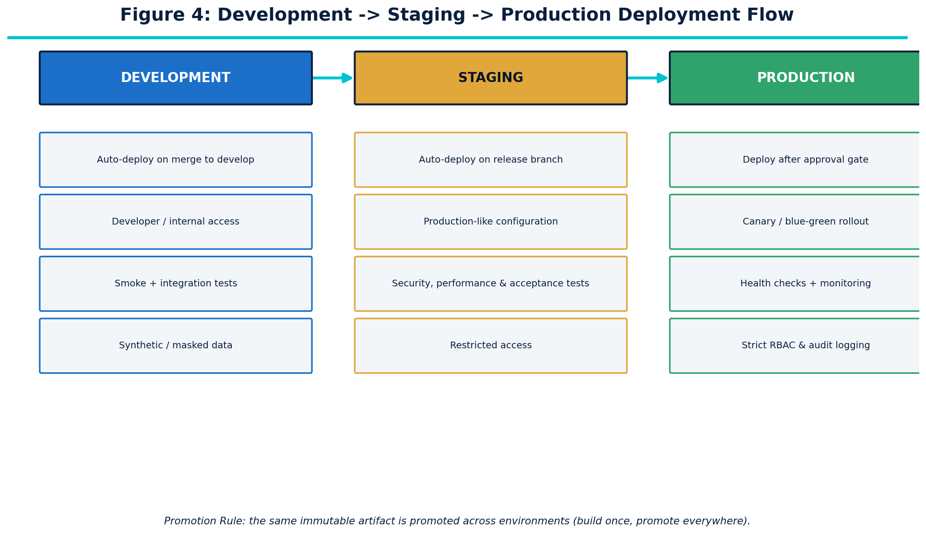
Figure 4: Development -> Staging -> Production Deployment Flow

13. Deployment Strategy
Strategy | Advantages | Risks/Drawbacks
Rolling Deployment | Simple, no extra infrastructure, gradual replacement of instances | Slower rollback, brief mixed-version state
Blue-Green Deployment | Instant cutover, near-zero downtime, simple rollback (switch back) | Requires duplicate production infrastructure
Canary Deployment | Exposes new release to a small subset first, limits blast radius, supports automated health-based promotion | More complex traffic management and monitoring

13.1 Recommended Strategy
Canary deployment, with Blue-Green as a fallback option for smaller releases, is recommended for CyberShield 360 because cybersecurity platforms require tightly controlled production changes. A canary release limits exposure of a new build to a small percentage of traffic or a subset of monitored assets, allowing automated health and security checks to confirm stability before full rollout.
- Why selected: minimises blast radius for a system that must remain continuously available for threat detection.
- Advantages: early detection of issues with limited impact; supports automated rollback triggers.
- Risks: requires additional traffic-routing and monitoring infrastructure to implement correctly.
- Rollback mechanism: automatic reversion to the previous stable version if canary health checks fail.
- Monitoring requirements: real-time comparison of error rates, latency, and detection accuracy between canary and stable versions.
Note: This section describes a proposed deployment strategy for CyberShield 360, not a strategy currently in use, since no implementation has been built as part of this exercise.

14. Quality Gates
Gate | Validation | Failure Action
Build | Build success | Stop
Unit Test | Critical tests pass | Stop
SAST | No blocking findings | Stop
SCA | No unacceptable vulnerabilities | Stop
Secret Scan | No secrets detected | Stop
Container Scan | No critical findings | Stop
Integration | Required tests pass | Stop
Staging | Security/acceptance tests pass | Stop
Production | Health checks pass | Rollback

15. Security Strategy
Because CyberShield 360 is itself a cybersecurity product, its delivery pipeline receives an especially strong security treatment. Key controls include:
- Least privilege for all pipeline identities and service accounts
- Role-Based Access Control (RBAC) across repositories, CI runners, and environments
- Multi-Factor Authentication (MFA) for all human access
- Secure handling of credentials via a dedicated secrets manager
- Protected branches with mandatory review and status checks
- Mandatory code review for every change
- Signed commits where appropriate, to verify author identity
- Artifact integrity verification (checksums/signing) before deployment
- Continuous dependency and container security scanning
- Isolated, ephemeral CI runners to limit lateral movement
- Network restrictions between pipeline components and environments
- Strict environment isolation between Development, Staging, and Production
- Mandatory deployment approvals for production releases
- Comprehensive audit logs for every pipeline action
- Continuous security monitoring of production workloads
Note: The CI/CD infrastructure itself is part of the system's attack surface and must be defended with the same rigour as the application it delivers.

16. Secrets Management
Sensitive values used by CyberShield 360 - including database credentials, API keys, threat-intelligence tokens, cloud credentials, and signing keys - must be stored in a dedicated secret-management system rather than in source code or configuration files.
- Secret rotation on a defined schedule and immediately after suspected exposure
- Access control restricting which pipeline stages and personnel can read which secrets
- Auditability - every access to a secret is logged
- Least privilege - each component receives only the secrets it needs
- Environment-specific secrets, so a Staging credential can never be used in Production
Note: No real secrets, credentials, or production infrastructure details are included anywhere in this document.

17. Artifact Management
- Build artifacts produced once per validated commit
- Container images tagged with immutable version identifiers
- Semantic versioning applied consistently across releases
- Central artifact repository with access control
- Immutable artifacts - never modified after creation
- Artifact promotion between environments without rebuilding
- Integrity checks (checksums/signatures) before deployment
- Defined retention policy to manage storage growth
Note: Guiding principle: build once, promote the same artifact through every environment. This guarantees that what is tested in Staging is exactly what runs in Production.

18. Rollback Strategy

18.1 Rollback Categories

Application Rollback
Return to the previous stable release by redeploying the last known-good artifact.

Container Rollback
Redeploy the previous, immutable container image version.

Configuration Rollback
Restore the previous validated configuration alongside the reverted application version.

Database Considerations
Use backward-compatible, additive migrations wherever possible, and avoid destructive schema changes that would block a rollback.

AI/ML Model Rollback
Return to the previously validated model version if a newly deployed model shows degraded detection performance or unsafe behaviour.

18.2 Rollback Triggers
- Health-check failure
- Critical security issue discovered post-deployment
- High error rate
- Service unavailability
- Unexpected application behaviour
- AI detection performance degradation
- Security incident escalation
Automated rollback is used for objective, measurable triggers such as failed health checks, while manual rollback (with human approval) is reserved for ambiguous situations that require judgement, such as a suspected but unconfirmed security incident.
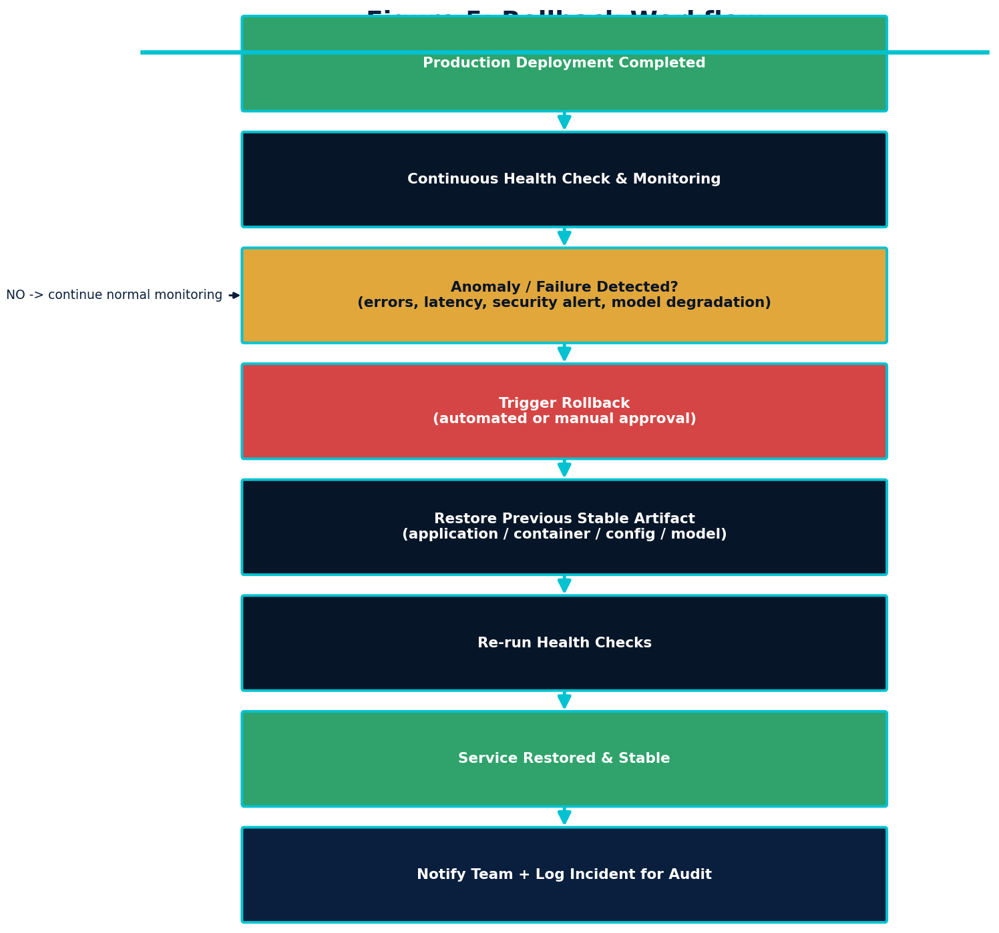
Figure 5: Rollback Workflow

19. Monitoring and Observability
The proposed monitoring architecture tracks the following signals:
- CPU and memory utilisation
- Application error rates
- API latency
- Event-processing latency
- Alert-generation timeliness
- Failed deployments
- Service availability
- Security events
- AI model health
- Model drift
- Threat-detection performance
Proposed tools: Prometheus and Grafana for metrics and dashboards, and ELK/OpenSearch for centralised log aggregation and search. Monitoring output feeds directly back into the CI/CD lifecycle - for example, a sustained rise in false negatives after a model release can trigger a rollback or a new development cycle.

20. Notification Strategy
The pipeline sends notifications for the following events:
- Build failure
- Test failure
- Security scan failure
- Deployment success
- Deployment failure
- Rollback triggered
- Critical vulnerability detected
- Production health degradation
Possible notification channels include email, Microsoft Teams, and Slack. No specific communication platform is assumed to already be configured for CyberShield 360; the choice would be finalised during implementation.

21. Branching Strategy
Note: main |-- develop | |-- feature/* |-- release/*
- Feature development happens on short-lived feature/* branches
- Pull requests are required to merge into develop
- Mandatory code review before any merge
- Merge controls (status checks, approvals) enforced on protected branches
- release/* branches stabilise a specific release for staging and production
- Hotfixes branch from main and are merged back into both main and develop
Branch protection improves both quality and security by guaranteeing that no code reaches main without passing automated checks and human review, closing off a common path for both defects and malicious changes.

22. CI/CD Workflow - End-to-End
- Developer creates a feature branch.
- Developer implements the change.
- Developer commits code.
- Push triggers CI.
- Code is checked out.
- Dependencies are installed.
- Build is executed.
- Unit tests execute.
- Code quality analysis runs.
- Dependency scan runs.
- Secret scan runs.
- Application/package is created.
- Container image is built if applicable.
- Image vulnerability scan executes.
- Integration/API tests execute.
- Artifact is stored.
- Development deployment occurs.
- Staging deployment occurs.
- Security and acceptance tests execute.
- Quality gate evaluates results.
- Approval occurs if required.
- Production deployment begins.
- Health checks execute.
- Monitoring begins.
- If healthy, release remains active.
- If unhealthy, rollback occurs.
- Notifications are sent.
- Results are recorded for audit and continuous improvement.

23. Failure Handling
Failure Type | Detection | Pipeline Action | Notification | Recovery
Build failure | Non-zero build exit code | Halt pipeline | Notify committer | Fix and recommit
Unit-test failure | Failing test report | Halt pipeline | Notify committer | Fix code/tests and recommit
SAST failure | Blocking finding reported | Halt pipeline | Notify committer + security lead | Remediate vulnerability
Dependency vulnerability | SCA scan flags critical CVE | Halt pipeline | Notify committer + security lead | Upgrade/patch dependency
Secret detected | Secret-scan match | Halt pipeline immediately | Notify security lead | Revoke secret, purge history, recommit
Container scan failure | Critical CVE in image | Block promotion | Notify committer + security lead | Rebuild from patched base image
Integration test failure | Failing integration suite | Halt pipeline | Notify team | Fix integration issue and rerun
Staging failure | Security/acceptance test fails | Block production promotion | Notify release team | Fix and repromote through pipeline
Deployment failure | Deployment step errors out | Abort deployment | Notify on-call/team | Investigate and redeploy
Health-check failure | Post-deploy check fails | Trigger rollback | Notify on-call/team | Restore last stable release
Monitoring failure | Anomalous metrics post-release | Alert + possible rollback | Notify on-call/team | Investigate, rollback if needed
AI model validation failure | Model metrics below threshold | Block model promotion | Notify ML/security team | Retrain or revert to prior model

24. AI/ML Model CI/CD (MLOps / AI Model Delivery Pipeline)
Note: Data -> Validation -> Model Training -> Model Testing -> Security/Quality Validation -> Model Registry -> Staging -> Model Evaluation -> Approval -> Production -> Monitoring -> Drift Detection -> Retraining/Rollback
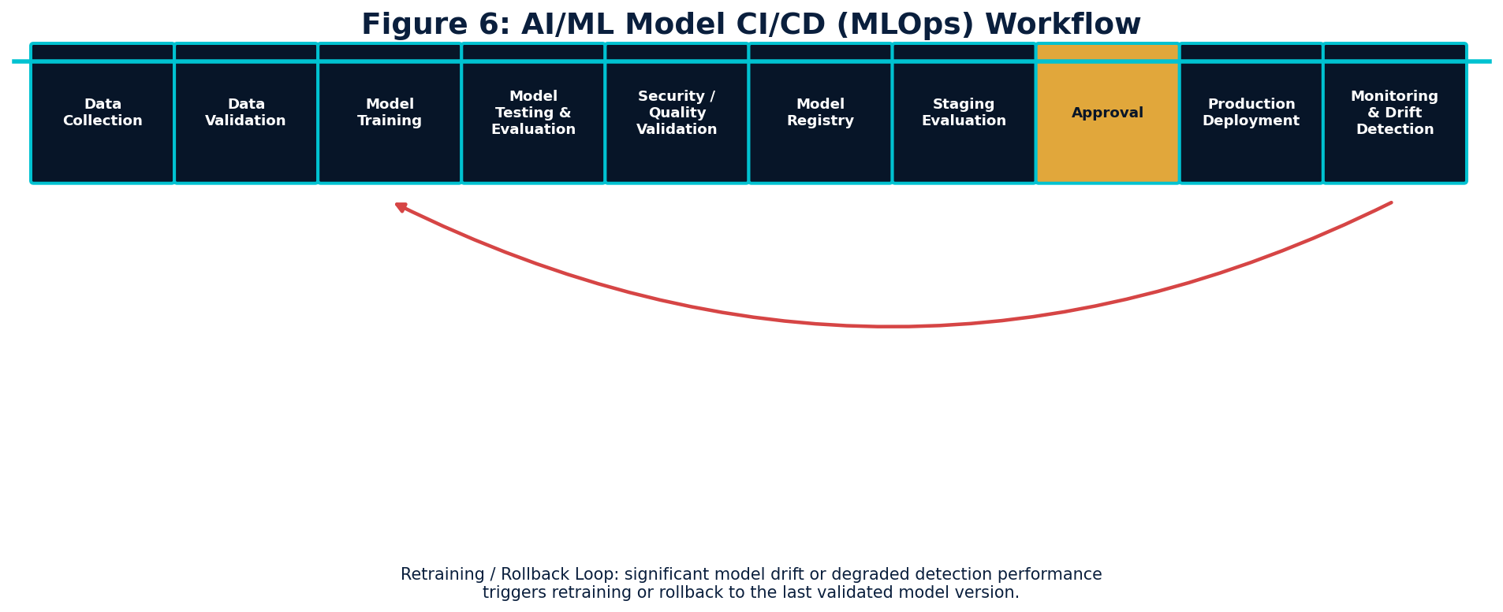
Figure 6: AI/ML Model CI/CD (MLOps) Workflow
This dedicated MLOps pipeline is especially important for CyberShield 360, since detection quality directly determines the platform's effectiveness. It covers:
- Dataset validation and data quality checks
- Model versioning alongside code versioning
- Model evaluation against held-out data
- Accuracy, precision, recall, and F1-score as candidate quality-gate metrics
- False-positive and false-negative rate tracking
- Bias evaluation across relevant data segments
- Explainability considerations for security analysts reviewing alerts
- Model drift monitoring in production
- Model rollback to the last validated version on degradation
Note: No actual model metrics are fabricated or reported in this document; all figures referenced above are proposed quality-gate categories to be measured once a real model exists.

25. Ethics and Responsible DevOps
CO4 explicitly requires attention to ethics alongside testing, quality assurance, and DevOps practice. For CyberShield 360, this means:
- Responsible automation - automated actions are scoped and reversible wherever possible
- Human approval required for high-impact security actions (e.g., automated blocking of user accounts)
- Privacy protection for monitored user and network data
- Data minimisation - collecting only what is necessary for security monitoring
- Secure handling and retention of logs containing sensitive activity data
- Responsible AI practice, including bias detection in threat-detection models
- Explainability so security analysts can understand why an alert was raised
- Auditability of every automated decision for later review
- Accountability - clear ownership for approvals and automated actions
- Avoiding unsafe deployment of unvalidated models or code to production
- Avoiding unauthorised automated actions that could disrupt legitimate business activity
Because CyberShield 360 can trigger automated responses (e.g., isolating a device), the pipeline must balance the speed automation provides with the safety of human oversight for consequential actions.

26. Reliability and Business Continuity
The proposed CI/CD pipeline supports CyberShield 360's business-continuity objective through:
- High availability via redundant deployment targets
- Fault tolerance through health checks and automated recovery
- Rapid recovery via automated rollback
- Controlled releases via staged promotion and approval gates
- Redundancy across critical monitoring components
- Disaster-recovery readiness through reproducible, versioned infrastructure
- Regular backup of configuration and artifact state
- Continuous monitoring to detect degradation before it becomes an outage
Because CyberShield 360 exists to protect an organisation's operations, any gap in its own availability directly weakens that protection - making pipeline-driven reliability a security requirement in its own right.

27. Pipeline Security Threat Model

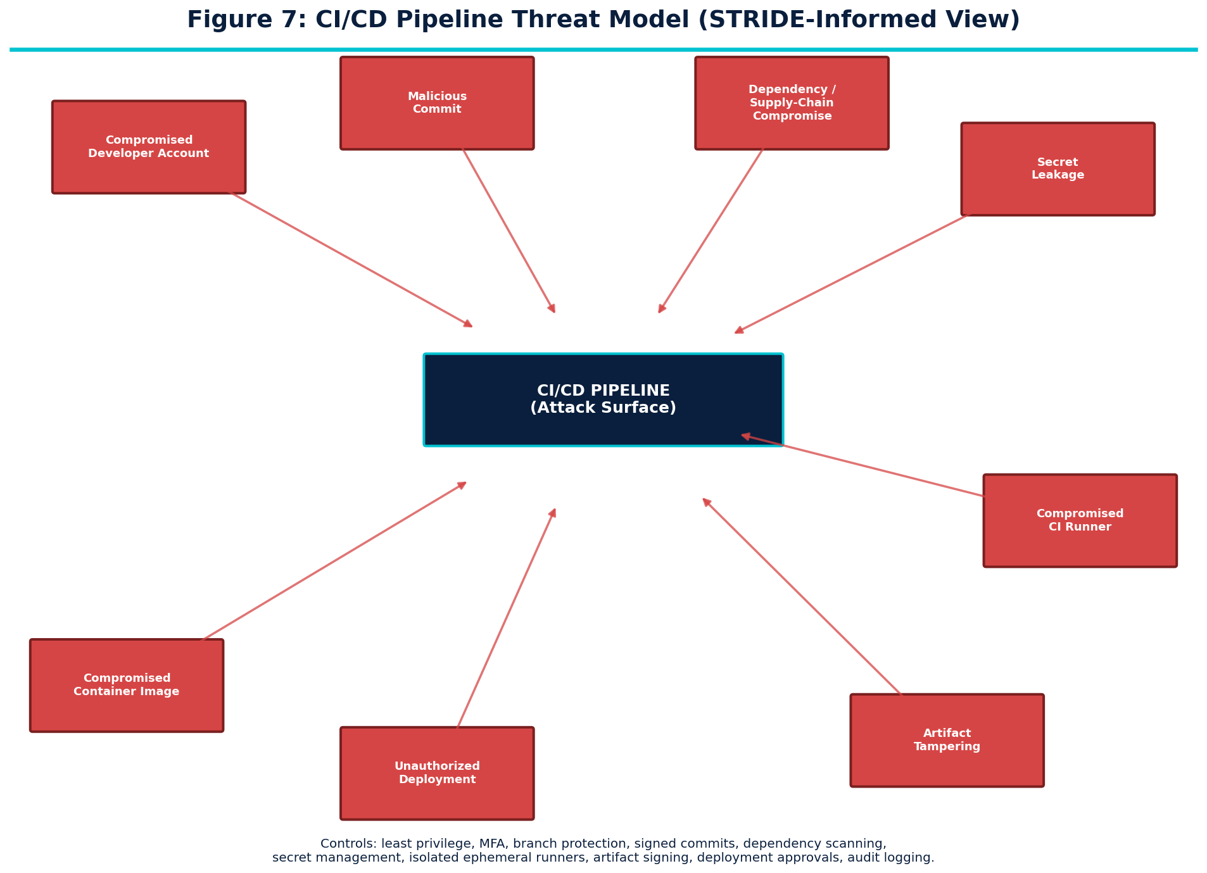
Figure 7: CI/CD Pipeline Threat Model
Threat | Impact | Preventive Control | Detection | Response
Compromised developer account | Malicious or unauthorised code merged | MFA, least privilege, branch protection | Anomalous login/commit alerts | Revoke access, force credential reset, audit commits
Malicious commit | Backdoor or vulnerability introduced | Mandatory code review, SAST | Static analysis findings, review flags | Revert commit, investigate, patch
Dependency compromise / supply chain | Vulnerable or malicious library included | SCA scanning, dependency pinning | CVE alerts, unexpected dependency changes | Remove/replace dependency, rebuild
Secret leakage | Credential exposure and misuse | Secret scanning, secrets manager | Scan alerts, unusual access patterns | Revoke and rotate credential immediately
Compromised CI runner | Arbitrary code execution in pipeline | Ephemeral, isolated runners; least privilege | Runner integrity monitoring | Destroy and recreate runner, audit pipeline logs
Artifact tampering | Unverified/modified artifact deployed | Artifact signing, checksum verification | Signature/checksum mismatch | Block deployment, rebuild from source
Unauthorised deployment | Unapproved change reaches production | RBAC, mandatory approval gates | Deployment audit logs | Roll back, review access controls
Compromised container image | Vulnerable/malicious image deployed | Image scanning, minimal base images, signing | Scan findings, image provenance checks | Block promotion, rebuild from trusted base

28. CI/CD Pipeline Metrics
Metric | Why It Is Useful
Build success rate | Indicates overall build stability and code health
Deployment frequency | Reflects delivery speed and pipeline efficiency
Lead time for changes | Measures time from commit to production
Change failure rate | Indicates how often releases cause issues
Mean time to recovery (MTTR) | Measures how quickly the team resolves failures
Test pass rate | Reflects test suite health and code quality
Code coverage | Indicates the proportion of code exercised by tests
Vulnerability count | Tracks security posture over time
Deployment rollback rate | Indicates release stability
Pipeline duration | Reflects developer feedback speed
Security scan duration | Balances thorough scanning against pipeline speed
Note: No actual metric values are reported here, since no pipeline has been implemented or executed as part of this design exercise.

29. Sample Pipeline Configuration
Note: Illustrative Configuration - Not Production Credentials. The example below is representative pseudocode/YAML for teaching purposes only and contains no real infrastructure details.
# Illustrative Configuration - Not Production Credentials
name: cybershield360-ci-cd

on:
push:
branches: [develop, release/*]
pull_request:
branches: [develop, main]

stages:
- build
- test
- quality
- security
- package
- staging
- production

build:
run: install-dependencies && compile

test:
run: run-unit-tests && run-integration-tests
fail_pipeline_on: critical_test_failure

quality:
run: static-code-analysis
gate: no_new_critical_issues

security:
run:
- sast-scan
- dependency-scan
- secret-scan
gate: no_critical_findings

package:
run: build-container-image && scan-container-image
gate: no_critical_cve

staging:
deploy_to: staging-environment
run: dast-scan && acceptance-tests
gate: security_and_acceptance_pass

production:
requires_approval: true
strategy: canary
deploy_to: production-environment
post_deploy: health-check
on_failure: automatic-rollback

30. Traceability Matrix
Req ID | Requirement | Pipeline Stage | Tool | Quality Gate | Verification
CI-CD-FR-01 | Source code version control | Source Code Management | Git | N/A | Branch protection audit
CI-CD-FR-02 | Automated build | Build | CI orchestrator + build tool | Gate 1 - Build | Build log review
CI-CD-FR-03 | Automated unit testing | Unit Testing | JUnit/PyTest/Jest | Gate 2 - Unit Test | Test report review
CI-CD-FR-04 | Integration testing | Integration Testing | CI orchestrator | Gate 5 - Integration | Integration test report
CI-CD-FR-05 | Security scanning | SAST/SCA/Secret/Container scan | SonarQube, Snyk, Gitleaks, Trivy | Gates 3-6 | Scan report review
CI-CD-FR-06 | Code-quality analysis | Static Code Quality Analysis | SonarQube | Gate 3 - Quality | Quality dashboard review
CI-CD-FR-07 | Artifact packaging | Container/Image Build | Docker | N/A | Artifact registry audit
CI-CD-FR-08 | Deployment automation | CD Deployment | CI orchestrator | N/A | Deployment log review
CI-CD-FR-09 | Environment promotion | Dev -> Staging -> Prod | CI orchestrator | Gates 6-7 | Promotion audit trail
CI-CD-FR-10 | Approval controls | Approval/Gate | CI orchestrator | Gate 7 - Approval | Approval record review
CI-CD-FR-11 | Automated rollback | Rollback Strategy | CI orchestrator/Kubernetes | N/A | Rollback log review
CI-CD-FR-12 | Deployment notification | Notification Strategy | Email/Teams/Slack | N/A | Notification log review
CI-CD-FR-13 | Monitoring | Monitoring & Observability | Prometheus/Grafana | Gate 7 - Health Check | Dashboard review
CI-CD-FR-14 | Audit logging | Security Strategy | ELK/OpenSearch | N/A | Audit log review
CI-CD-FR-15 | AI/ML model validation | MLOps Pipeline | Model registry/eval tools | Model Validation Gate | Model evaluation report

31. Rubric Mapping
Rubric Criterion | Document Section | Evidence of Excellent Performance
Requirement & Pipeline Analysis (15%) | Section 4 - CI/CD Requirements Analysis | Comprehensive functional and non-functional CI/CD needs derived from CyberShield 360
Pipeline Architecture & Workflow (25%) | Sections 5, 6, 22 - Architecture, Pipeline Stages, End-to-End Workflow | Complete, consistent end-to-end pipeline covering source through rollback
Tools & Technology Selection (20%) | Sections 9-10 - Tool Selection & Justification | Every major tool justified against security, integration, scalability, and reliability
Automated Testing & Quality Integration (15%) | Section 7 - Automated Testing Strategy | Unit, integration, API, regression, security, and AI/ML testing all integrated into CI/CD
Deployment, Security & Rollback (15%) | Sections 12-18 - Environments, Deployment Strategy, Gates, Security, Rollback | Staged environments, justified deployment strategy, explicit gates, rollback design
Pipeline Diagram & Documentation (10%) | Section 11 and Figures 1-7 | Seven clear, professional, consistent diagrams supporting the written pipeline

32. Conclusion
This document has proposed a complete CI/CD pipeline architecture for CyberShield 360, an AI-based enterprise cybersecurity monitoring and threat intelligence system. The proposed pipeline automates software delivery from commit to production, improving quality through layered automated testing and integrating security throughout every stage rather than at the end. Continuous testing - unit, integration, API, regression, and security - together with explicit quality gates, substantially reduces the risk that defective or insecure changes reach production.
A dedicated MLOps track supports the responsible delivery and monitoring of AI/ML detection models, while staged environments, a justified canary-based deployment strategy, and a clearly defined rollback mechanism together enable reliable, low-risk releases. Continuous monitoring closes the loop by feeding operational and security signals back into development, and the pipeline's own threat model and security controls acknowledge that the delivery system is itself part of the attack surface that must be defended.
Taken together, this design promotes scalable, auditable, and ethically responsible DevSecOps practice, directly satisfying CO4's requirement to implement robust testing, quality assurance, and DevOps practices with emphasis on security, reliability, and ethics.

33. References
- NIST Special Publication 800-204D, Strategies for the Integration of Software Supply Chain Security in DevSecOps CI/CD Pipelines - National Institute of Standards and Technology.
- OWASP Foundation, OWASP Top Ten and OWASP DevSecOps Guideline - owasp.org.
- OWASP Foundation, OWASP Dependency-Check Documentation - owasp.org/www-project-dependency-check.
- Docker Inc., Docker Documentation - docs.docker.com.
- The Kubernetes Authors, Kubernetes Documentation - kubernetes.io/docs.
- Git, Pro Git Book - git-scm.com/book.
- GitHub Inc., GitHub Actions Documentation - docs.github.com/actions.
- GitLab Inc., GitLab CI/CD Documentation - docs.gitlab.com/ee/ci.
- SonarSource, SonarQube Documentation - docs.sonarsource.com.
- Aqua Security, Trivy Documentation - aquasecurity.github.io/trivy.
- Gitleaks Project, Gitleaks Documentation - github.com/gitleaks/gitleaks.
- Prometheus Authors, Prometheus Documentation - prometheus.io/docs.
- Grafana Labs, Grafana Documentation - grafana.com/docs.
- Google Cloud, MLOps: Continuous Delivery and Automation Pipelines in Machine Learning - cloud.google.com/architecture/mlops-continuous-delivery-and-automation-pipelines-in-machine-learning.
- NIST AI Risk Management Framework (AI RMF 1.0) - nist.gov/itl/ai-risk-management-framework.

